|  |  |  |
| --- | --- | --- |
| Product Name | IDC connector (horn/mini-horn) |  |
| Connector type | Mini-horn seat |  |
| Spacing | 2mm |  |
| Row number | 2 |  |
| Line spacing | 2mm |  |
| Packaging form | Straight insertion |  |
| Contact material | Grass |  |
| Contact coating | Gold |  |

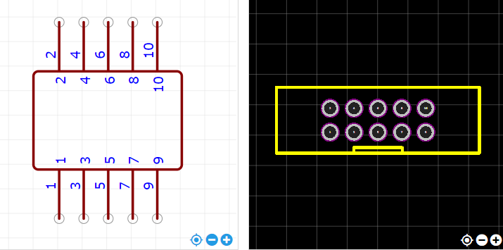

<https://item.szlcsc.com/221677.html>